## Advanced Hybrid RTUs

### Author

* Andrew Parker, NREL

### Description

Advanced hybrid RTUs combine traditional DX cooling with indirect evaporative cooling and variable-speed drive fans to achieve energy and peak demand savings, particularly in hot dry climates. The increased fan power due to the indirect evaporative cooler may increase energy consumption in humid or heating-dominated climates. However, this penalty is often outweighed by the benefit of the reduced flow rate possible because of the variable speed drive.

### Modeler Description

Each packaged single zone system in the model will be replaced with an advanced hybrid RTU consisting of a 100% effective indirect evaporative cooler, a two speed DX cooling coil, the existing heating coil, and a variable speed fan. Fan power will be increased by 0.5 inches of water column above the current fan pressure rise to represent the addition of the indirect evaporative cooler.

### Use Case Types

Retrofit, New Construction

### Arguments

“run_measure” is a choice argument that determines whether or not the Measure is applied during a given run.

### Initial Condition Message

### Final Condition Message

The number of air loops that were converted to advanced hybrid RTUs

### Not Applicable Messages

Not applicable if no air loops were converted.

### Warning Messages

Warn if no supply fan or cooling coil is found on a loop.

### Information Messages

List each loop that has a fan, cooling coil, or indirect evaporative cooler added or modified.

### Error Messages

### Code Outline

* Loop through all airloops
* Skip any that serve more than one zone
* Add a 100% effective indirect evaporative cooler to the OA intake. Make the secondary fan VSD by applying a fan power curve.
* Find the fan; if it is variable speed, modify the curve
* If it isn’t, preserve the fan and motor efficiency and pressure rise and transfer them to a variable speed fan, then delete the old fan.
* Find the cooling coil. If it is already a 2 speed DX, modify the COP. Otherwise, delete the existing coil and replace with a 2 speed DX.
* Modify the system sizing to be 100% OA in cooling and lower the minimum flow fraction to allow the VSD to drop the fan flow.
* Apply a differential drybulb economizer that compares the IDEC leaving condition to the return air.

### Tests

**This measure applies to:**

1. Primary School
2. Secondary School
3. Large Hotel
4. Small Office
5. Stand-Alone Retail
6. Strip Mall
7. Quick Service Restaurant
8. Full Service Restaurant
9. Warehouse

### Test results

This is a test in Houston, TX, which is hot but humid. Not the ideal climate for these systems.

The DX coil does less cooling and the evap cooler does more cooling.

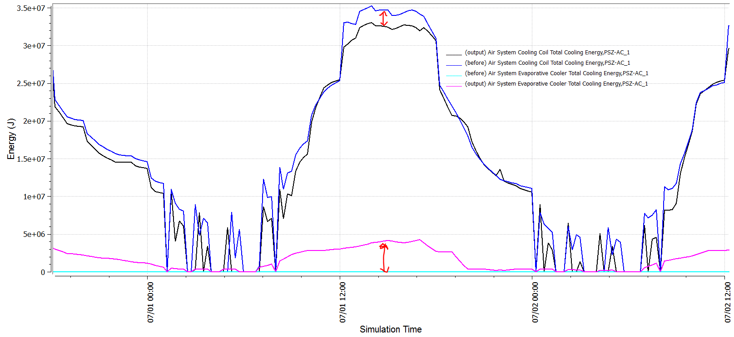

Air flow is reduced because the VSD allows the fan to throttle back.

### 

Fan energy goes down with the air flow. The decrease in flow outweighs the pressure rise penalty of the evaporative cooler.

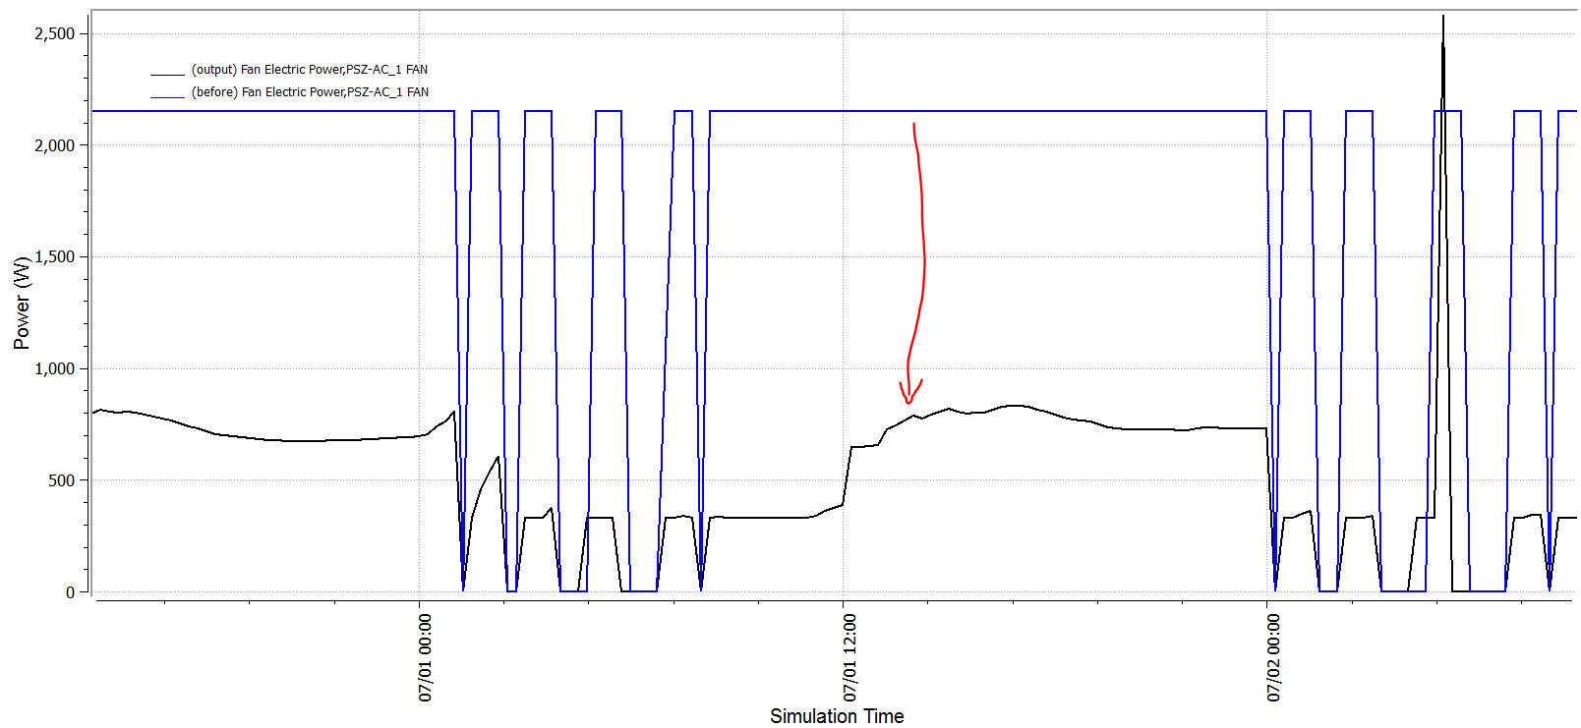

### References

1. Energy Simulation Results for Indirect Evaporative-Assisted DX Cooling Systems; Dirkes & Hoffman, ASHRAE Transactions 2011